**ASSIGNMENT 22.1**

PROBLEM STATEMENT:

**Go through below blog and reiterate the same at your end**.

<https://docs.google.com/document/d/1csLBlMiEXs_hXWV2Z8VpBlrj_R6RoDQLlZUnA0uBTCk/edit>

**1. Find out the state wise population and order by state.**

Solutions:





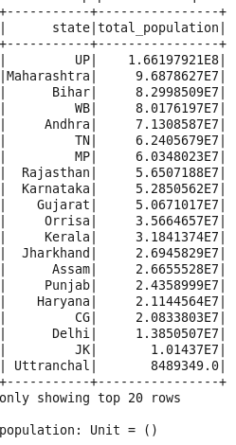

**2. Find out the Growth Rate of Each State Between 1991-2001**

Solutions:

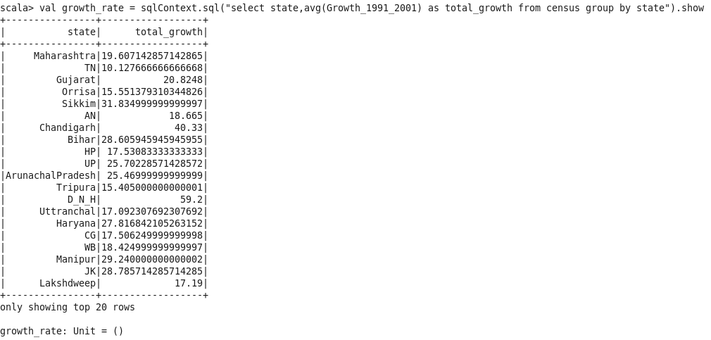

**3. Find the literacy rate of each state**

Solutions:

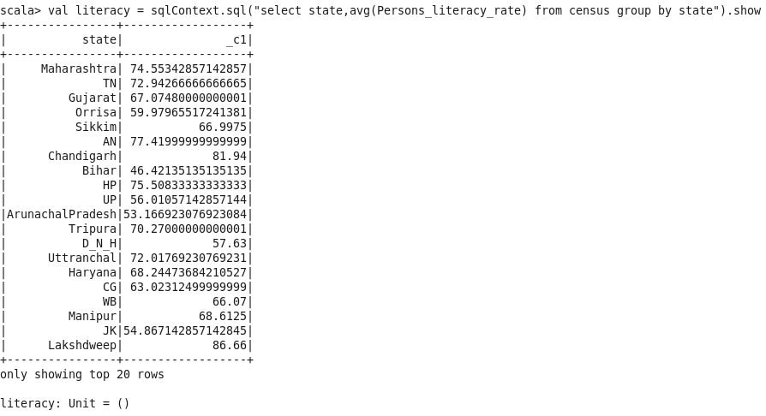

**4. Find out the States with More Female Population**

Solutions:

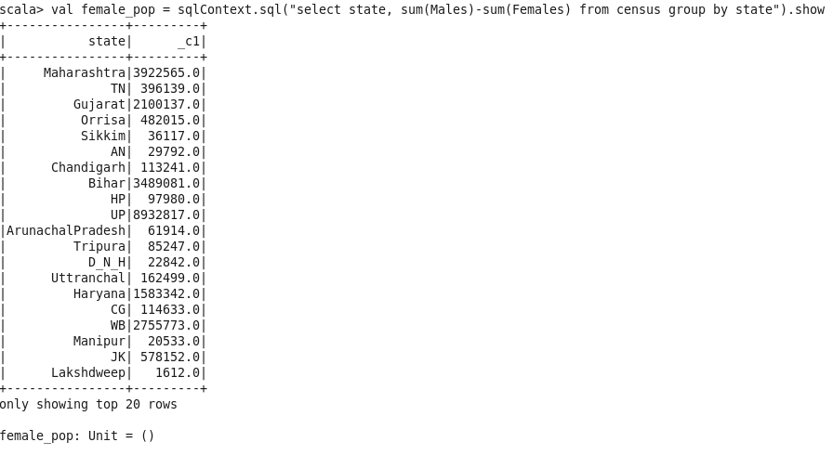

**5. Find out the Percentage of Population in Every State**

Solutions:

